Written Assignment Unit 1

Department of Information Technology, University of the People.

**MSIT 5250-01:** Foundations of Software Engineering

**Assignment Title:** Transitioning De Don's Electronics from Bricks to Clicks: A Human-Centered Approach

Instructor: Dr. [Ada Ajunwa](https://my.uopeople.edu/user/view.php?id=58721&course=8411)

November 17, 2024

### **Introduction**

De Don's Electronics, a cherished local electronics store, is embarking on an ambitious transition to an exclusive online retail model, and this paper details the strategies, methodologies, and technologies essential for a seamless digital transformation.

### **Store Overview**

1. **Store Name:** De Don Electronics
2. **Type:** Electronics Retailer

De Don's Electronics is shifting from its familiar physical locations to the online sphere, aiming to enhance customer accessibility with a vibrant e-commerce site and a cutting-edge mobile app while ensuring superior database management and security.

### **SDLC Approach**

We will leverage Kanban and SCRUM methodologies to effectively navigate this transition, utilizing Kanban for visualizing workflow and SCRUM for iterative development, both of which will provide the flexibility and adaptability needed for this complex project.

### **Kanban Approach**

Kanban will be employed to streamline task management, allowing us to visually track progress and swiftly address any workflow bottlenecks, ensuring each phase of website development, app design, and database management progresses smoothly.

### **SCRUM Approach**

SCRUM will guide our development through iterative sprints, focusing each cycle on key project aspects like website features or app integration, with daily standups, sprint reviews, and retrospectives ensuring continuous improvement and team alignment.

### **Applying the SDLC Methods**

1. **Kanban Implementation:**  
   We will use a Kanban board to categorize and prioritize tasks, moving them through stages from "To Do" to "Done" to efficiently manage workflow and adapt to changes.
2. **SCRUM Implementation:**  
   Our project will be divided into sprints with specific goals, featuring daily standups to discuss progress, sprint reviews to assess outcomes, and retrospectives to refine our approach.

### **Programming Languages**

We will use HTML/CSS for website design, JavaScript for interactivity, PHP/Python for backend operations, SQL for database management, and Swift/Kotlin for mobile app development to construct a successful online presence.

1. **Requirements**

Successfully transitioning De Don's Electronics to an online store involves meeting several key requirements:

1. **Website Development**

Tools like Adobe XD for design, Visual Studio Code for coding, and Selenium for testing will ensure the creation of a user-friendly and functional e-commerce website.

1. **Mobile App Development**

Using Xcode and Android Studio for app development, InVision for prototyping, and Appium for testing will help build and launch seamless mobile applications for iOS and Android.

1. **Database Management**

MySQL Workbench for design, MySQL or PostgreSQL for database management, and New Relic for performance monitoring will facilitate efficient and secure database operations.

1. **Data Security**

Implementing SSL/TLS certificates via Let’s Encrypt, user authentication through Auth0, and conducting security audits with OWASP ZAP will ensure robust protection of sensitive data.

1. **Scalability and Performance**

Tools like Apache JMeter for load testing, Cloudflare for content delivery, and Redis for caching will optimize the performance and scalability of the e-commerce platform.

1. **Testing and Quality Assurance**

Jest and JUnit for automated testing, GitHub and Jenkins for CI/CD pipelines, and Jira and Bugzilla for bug tracking will support thorough testing and quality assurance throughout the development process.

1. **GitHub Account with the scenario document**

Attached below is the URL to the GitHub where the screenshot was taken: <https://github.com/vekis11/De-Don-Electronics>

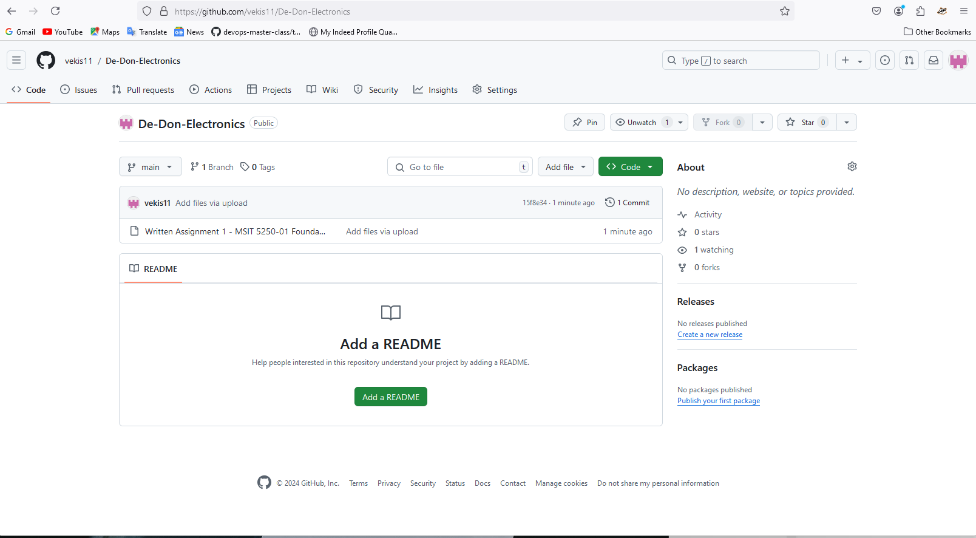

**Conclusion:**

De Don's Electronics is set to embark on an exciting digital journey. By employing Kanban and SCRUM methodologies, choosing the right programming languages, and addressing essential requirements, we aim to create a seamless online shopping experience that meets the needs of our customers. This transition will modernize the business and enhance customer satisfaction and engagement in the digital age.

**References:**

* Boehm, B. W. (1988). A Spiral Model of Software Development and Enhancement. ACM SIGSOFT Software Engineering Notes, 11(4), 14-24. https://doi.org/10.1145/74219.74221
* Highsmith, J. (2002). Agile Software Development Ecosystems. Addison-Wesley.
* Sommerville, I. (2011). Software Engineering (9th ed.). Addison-Wesley.